产品规格承认书
SPECIFICATION FOR APPROVAL

客户名称：
CUSTOMER：
产品名称：
PRODUCT NAME： 方形保险丝
型号规格：
MODEL DETAIL： AST T1A 250V
物料编码：
MATERIEL CODE.：

编 制  PREPARED BY | 审 核  CHECKED BY | 批 准  APPROVED BY |  | 承 认  SIGNATURE | 审 核  CHECKED BY | 批 准  APPROVED BY

供方签章： 客户签章：

SUPPLIER： CUSTOMER：

日 期：2017.9.22 日 期：

DATE： DATE：

备注：承认签章后请回复一份承认书（或复印件）给我司，其余由贵司留作存档。如果在签章的承认书（或复印件）回复给我司之前，下了有关此零件的订单且又无特别说明，那么我司就确定贵司已完全承认了。

Please return one specification or one copy of it with your chop and signature of approval and retain the others for your record. In the event of an order being placed for this part number before the chop and signed with specification (or copy) is returned and without special explanation, it will be assumed that full approval have been given.
 | PRODUCT  SPECIFICATION | EDITION NO. | A/0
 | PRODUCT  SPECIFICATION | FILE NO. | AL/A-013-08
 | MODEL：AST | PAGE | PAGE 1 OF 5

1. 适用范围Scope of application
本产品适用于各种电子机器内的电路中起过电流保护作用.
This product is suitable for various kinds of electronic machines to work for over current protection.
2.相关标准及认证Relevant Standards and Certification
2.1执行标准Standards：IEC60127-1 IEC60127-3 GB9364.1 GB9364.3
3. 结构及尺寸Structure and Size (unit: mm)

- 原材料明细 Material Details

编号 No. | 零件名称Part Name | 材质 Material
① | 熔丝Fuse element | 合金线Alloy
② | 内芯 Core | 尼龙Thermoplastic Nylon
③ | 外壳 Case | 尼龙Thermoplastic Nylon
④ | 引线Lead wire | 镀锡铜线Tinned copper wire

5. 标示 Marking
5.1 保险丝应有下列标示The fuse shall have the following marking :
1) 延时符号 Time-lag Symbol：T
2) 额定电流 Ampere rating：1A
3) 额定电压 Voltage rating：250V

4) 认证符号 Approved Symbol
 | PRODUCT  SPECIFICATION | EDITION NO. | A/0
 | PRODUCT  SPECIFICATION | FILE NO. | AL/A-013-08
 | MODEL：AST | PAGE | PAGE 2 OF 5

6. 外观Appearance
6.1外观不应有显著的污点、裂纹。
There shall not be any remarkable stain，rust or crack on the appearances.
6.2标示应该很容易辨识。
Marking shall be easily legible.

7. 机械特性Mechanical characteristics
7.1 拉力强度试验Tensile test
将保险丝固定好后，对保险丝引线施加5N的拉力，持续1分钟。试验过后，保险丝没有任何破损现象。
Exert the axial pulling force of 5N to the both ends of lead wire for 1 minute. After the test the fuse shall be no damage and loosening.
7.2 推力试验(Thrust Test)
将保险丝保持在一个固定的位置，沿引线方向旋加2N的推力，引线、方形塑料不能松动并且方形塑料不应破裂。
When fuse is fixed and the thrust 2N is applied in a direction to lead, no looseness of leads and square thermoplastic cap or damage of square thermoplastic cap shall occur.

8. 电气特性Electrical characteristics
8.1 实验条件Test condition
所有测试环境温度为25±5℃。
All electrical characteristics tests are conducted at an ambient temperature of 25±5℃.
8.2 分断能力Interrupting rating test
保险丝能承受的分断能力：35A或10倍的额定电流当中较大的。分断能力测试后测得保险
丝的绝缘阻抗值大于0.1ΜΩ。
The fuse interrupting capacity：35A or 10 times the rated current whichever is greater. After
interrupting, the insulation resistance between the fuse terminations shall be not less than 0.1ΜΩ.
8.3 温度上升试验：通1.5倍额定电流15分钟，然后每隔15分钟增加0.1倍额定电流。测得保
险丝断开时任何部位的温升不得超过135℃，周围环境温度为25±5℃。
Temperature Rising Test: The rated current of 1.5 times is applied for 15 minutes. After the first
15minutes, the current is increased by 0.1 times the rated current every 15 minutes until the fuse
operates. The temperature rising on the fuse surface is not higher than 135℃.

 | PRODUCT  SPECIFICATION | EDITION NO. | A/0
 | PRODUCT  SPECIFICATION | FILE NO. | AL/A-013-08
 | MODEL：AST | PAGE | PAGE 3 OF 5

8.4 时间-电流特性 Time-Current Characteristics
额定电流的% % of ampere rating | 熔断时间 Opening time
210% | 2 min Max
275% | 400 ms~10 s
400% | 150 ms~3 s
1000% | 20 ms~150 ms
8.5 耐久性测试 Endurance test
8.5.1 对保险丝通过相关标准规格单规定的额定电流1小时,然后截断电流15分钟,将该循环重复
100次。试验过后保险丝没有任何破损现象。
A ampere rating specified in the relevant standard sheet is passed through the fuse for a period of
1h.The current is then switched off for a period of 15 minutes. This cycle is repeated 100 times. After
the test the fuse shall be no damage and loosening.
8.5.2 然后对熔断体通以1.5倍额定电流1小时；并测量两端电压降，计算其最大功耗不能超过上表所规定的最大值。
Fuse through to 1.5 times the rated current of 1 hour; and measure the voltage drop across, to calculate the maximum power consumption can not exceed the above table under the maximum
8.5.3 测量熔断体两端的电压降,且电压降的增大量不大于试验前测得值的10%。
Measuring both ends of the fuse voltage drop, and a large number of the increased voltage drop is not greater than 10% of the measured value before the test.
8.5.4 试验后,标记仍应清晰可辨，而且诸如端帽上的焊点不应出现任何明显的劣变。
After the test, the marking shall still be legible and soldered joints on end caps, for example, shall not show and appreciable deterioration.
8.6 焊接参数 Soldering parameters
8.6.1 波峰焊 260℃,最大10秒，
Wave soldering 260 ℃,10 sec. Maximum
8.6.2 手工焊 370℃,最大5秒，
Manual soldering 370℃, 3 sec. Maximum

 | PRODUCT  SPECIFICATION | EDITION NO. | A/0
 | PRODUCT  SPECIFICATION | FILE NO. | AL/A-013-08
 | MODEL：AST | PAGE | PAGE 4 OF 5
8.7 时间电流曲线图 Time- current curve
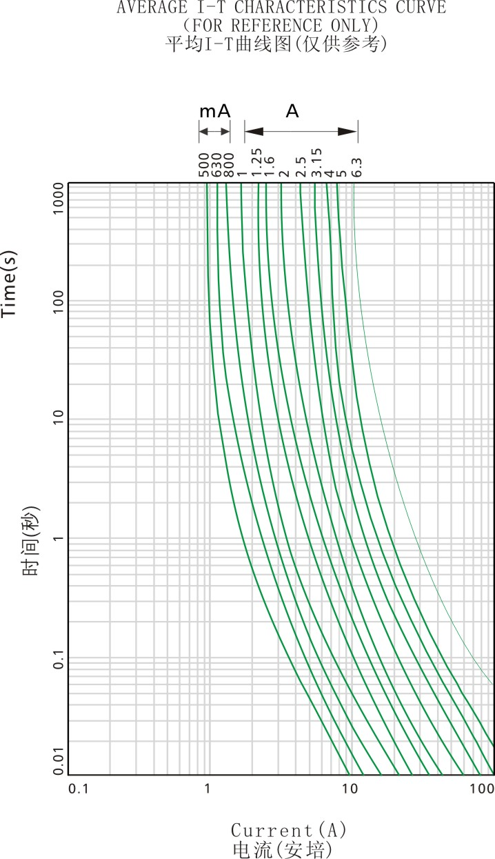

 | PRODUCT  SPECIFICATION | EDITION NO. | A/0
 | PRODUCT  SPECIFICATION | FILE NO. | AL/A-013-08
 | MODEL：AST | PAGE | PAGE 5 OF 5

9. 环境特性Environmental characteristics
9.1使用温度范围 Operating Temperature
-55℃～125℃。
9.2 保存条件Storage Conditions
相对湿度≦75%，可存放3年。
Relative humidity ≦ 75%, store 3 years .

10. 包裝Packing
10.1 包装方式：500PCS/小袋、3小袋/内盒、10内盒/外箱，自动机器编带1000PCS/内盒、10内盒/外箱(实际装箱依客户订单)。
纸盒规格： 长×宽×高＝180×160×80mm;
外箱规格： 长×宽×高＝425×375×180mm;
Packing Details:500 fuses per plastic bag, 3 plastic bags per inner box, 10 inner boxes per external carton. Automaton taped 1000 PCS per inner box, 10 inner boxes per external carton.(The actual case in accordance with the customer order)
Inner box dimension: Length×Width×Height＝180×160×80mm
External carton dimension: Length×Width×Height＝425×375×180mm
10.2 标签应包括：型号、额定电流、额定电压、额定分断电流、商标、安全标志、批量号码、公司标志、绿色的签章、RoHS & Pb-Free标志。
The label in the smallest packing in which the fuses are put shall contain the Type, Rated Current, Rated Voltage, Interrupting Rating, Safety Approval Logo, Lot No., Trademark, seals in green, RoHS & Pb-Free mark.
10.3 产品的包装应能达到防潮、抗振的作用。以防在运输或贮存过程中产品受潮或受损坏。
Packing shall meet the requirements of anti-moisture and anti-shaking so that the products will not absorb moisture or be damaged during transportation or storage.

